Sprint 2: Core Operations and Leave Management

Sprint 2 Overview
Sprint Duration: March 13, 2026 – March 25, 2026 Sprint Goal: Finalize core administrative controls and implement the leave and attendance infrastructure.
Modules Developed in Sprint 2: Role-Based Access Control (RBAC): (Completed; carried over from Sprint 1)
- Update Employee Information: (Completed; carried over from Sprint 1)
- Leave Management
- Attendance Tracking
- Employee Search

User Stories
User Story 1 – Apply for Leave
As an employee I want to submit leave requests So that I can request time off
Sub User Stories:
- Validate leave balance before submission.
- Store leave request details (type, start date, end date).
- Notify the respective manager for approval.
- Display leave submission confirmation to the employee.
User Story 2 – Approve/Reject Leave
As a manager I want to approve or reject leave requests So that workforce availability is managed
Sub User Stories:
- View a list of pending leave requests from team members.
- Change request status to "Approved" or "Rejected."
- Update the employee's leave balance upon approval.
- Maintain a history of leave decisions.
User Story 3 – Mark Daily Attendance
As an employee I want to mark check-in and check-out timestamps So that my working hours are accurately recorded
Sub User Stories:
- Capture current system timestamp for check-in/out.
- Calculate total daily working hours.
- Prevent duplicate check-ins for the same day.
- Provide immediate visual confirmation of the status.
User Story 4 – Search Employee
As an HR manager I want to search for employees So that I can quickly locate specific records
Sub User Stories:
- Filter employees by name, department, or role.
- Display a summarized list of matching results.
- Provide a direct link to the full employee profile from search results.
- Ensure search results only show data authorized for the HR role.

Structured Specifications
1. Leave Application Management
Field | Description
Function Name | Submit Leave Request
Module | Leave Management
Description | Processes employee requests for time off and routes them for approval
Inputs | Employee ID, Leave Type, Start Date, End Date
Processing | 1. Validate if the employee has sufficient leave balance  2. Save request to the database with "Pending" status  3. Trigger notification to the assigned Manager
Outputs | Success: Submission confirmation message  Failure: Error message (e.g., Insufficient balance)
Preconditions | Employee must be logged in and active
Postconditions | Leave request is logged and visible on the Manager's dashboard
Exceptions | Database connection error, End date precedes start date
2. Attendance Management
Field | Description
Function Name | Mark Daily Attendance
Module | Attendance Tracking
Description | Records daily clock-in/out times to track workforce hours
Inputs | Employee ID, Timestamp
Processing | 1. Identify if entry is check-in or check-out  2. Record timestamp in the attendance table  3. Calculate total hours if the action is a check-out
Outputs | Attendance confirmation message
Preconditions | Employee must be authenticated
Postconditions | Daily work record is updated in the system
Exceptions | System time sync error, Missing check-in for a check-out attempt
3. Employee Search
Field | Description
Function Name | Search Employee Records
Module | Core Employee Management
Description | Allows authorized users to find employees using specific criteria
Inputs | Search String (Name/Dept/ID)
Processing | 1. Verify user's search permissions  2. Query the database for matching strings  3. Return a list of active and/or inactive records
Outputs | List of matching employee profiles
Preconditions | User must have HR Manager or Admin role
Postconditions | Matching results displayed on screen
Exceptions | No records found, Unauthorized access attempt

4. Structured Specification - Approve/Reject Leave
Field | Description
Function Name | Approve or Reject Leave Request
Module | Leave Management
Description | Allows a manager to review and decide on employee leave submissions
Inputs | Leave Request ID, Action (Approve/Reject), Comments
Processing | 1. Verify user role as Manager or Admin.  2. Retrieve the specific leave request.  3. Update status to "Approved" or "Rejected".  4. If approved, deduct the duration from the employee’s leave balance.
Outputs | Status update confirmation message
Preconditions | Leave request must exist in "Pending" status; Manager must be logged in.
Postconditions | Employee leave balance is updated (if approved); Status is permanently logged.
Exceptions | Unauthorized access attempt; Request already processed.

Trello Screenshots: 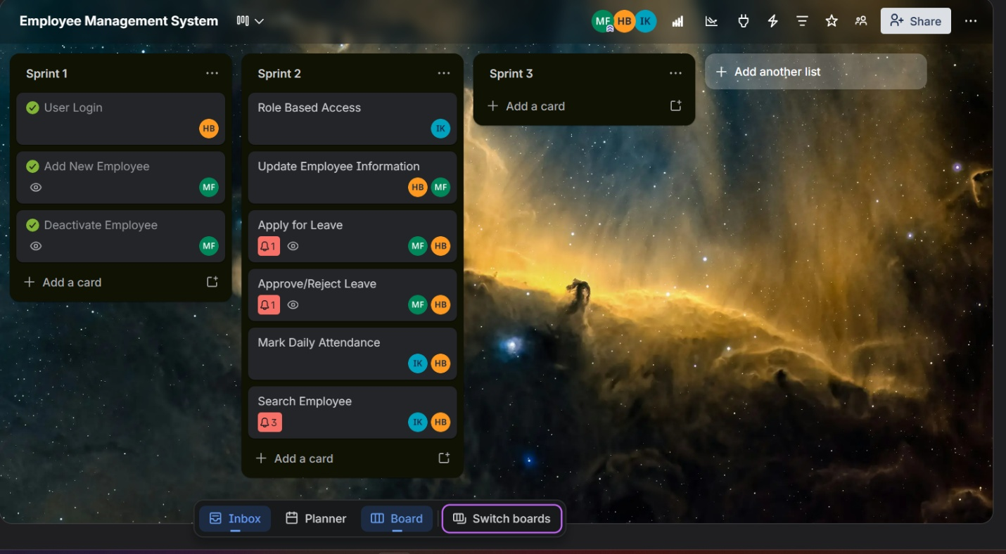
Figure 1: Start of Sprint
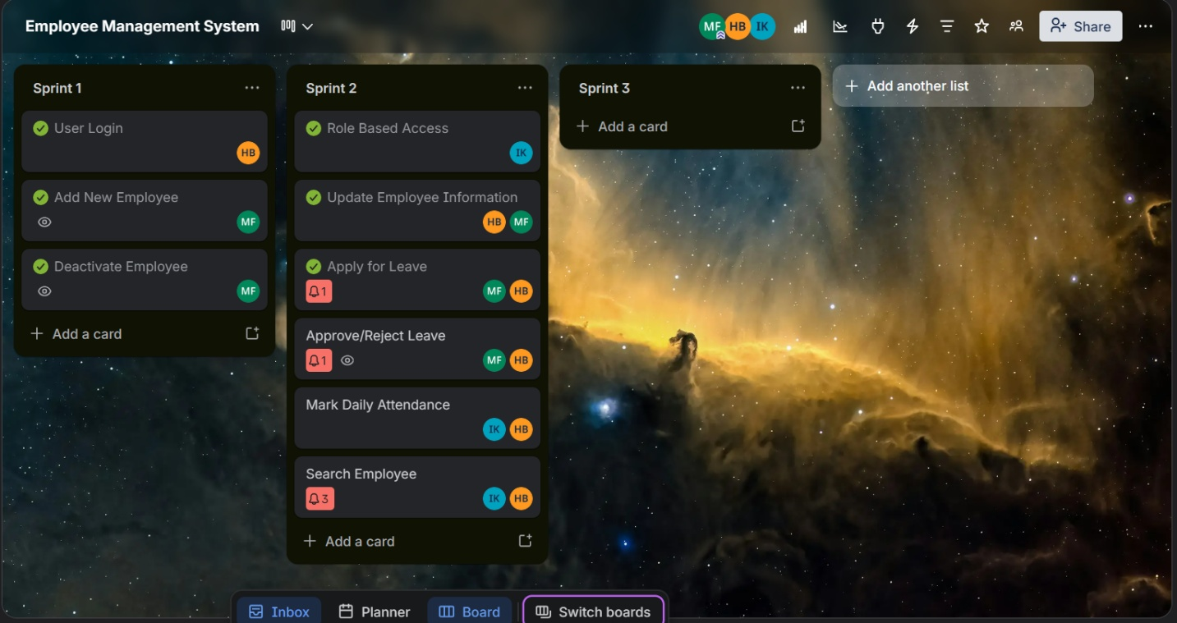
Figure 2: Middle of sprint (18th March)
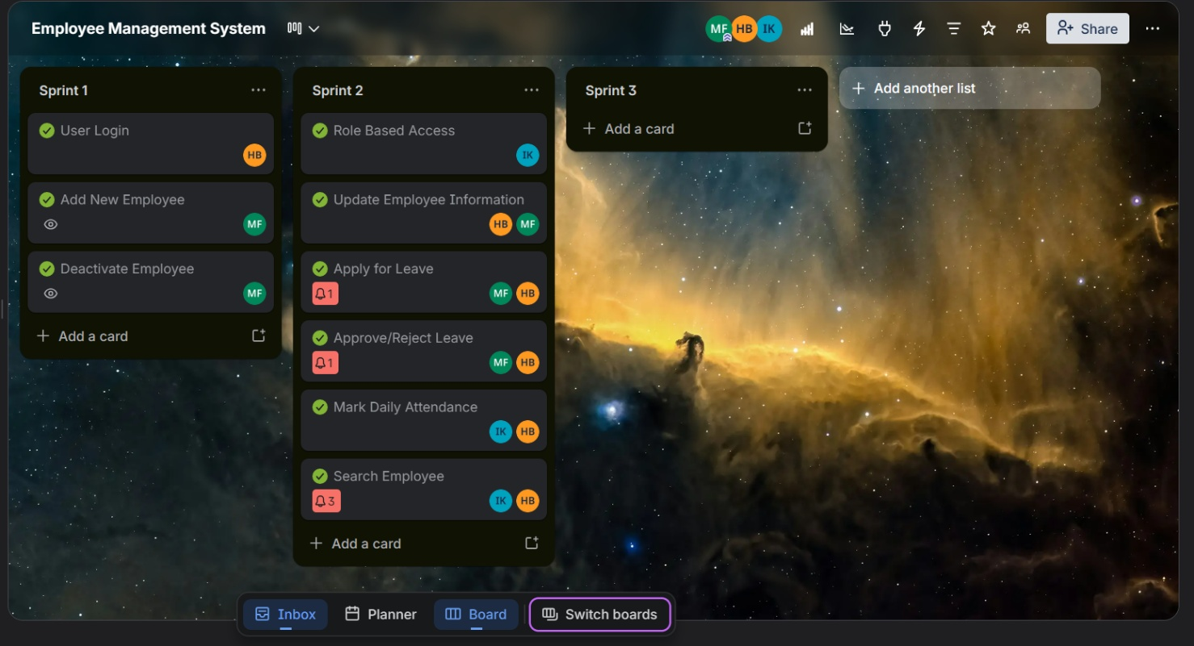
Figure 3: End of Sprint

Burndown chart:
